Oil Change Minder (Time/Distance/Oil Wear) Function - 10K & Diesel – V36x Specific -CGEA1.3

Functional Description

The V36x program has a unique request. Due to high engine warranty, it was determined that customers are simply resetting the oil life warning WITHOUT actually changing the oil. This has led to the request to add a unique DE10 configuration bit (HMI: Oil Minder Menu) that would allow you to disable the oil life reset menu display in the cluster. The normal config is still used, since we still want the 2 warnings. At this time, this will be limited to S0, S1, S2 level clusters. This is why the new config bit will be put in the S-family specific HMI area in DE10 and not into the global config. At this time, we do not want to add this to other programs. (As an FYI, the customer will have to use the PCM controlled “hidden” method of using the accelerator pedal to reset oil life).

This STSS replaces the legacy Oil Change Minder function (Oil Change Minder.doc) for most 2010 MY vehicles, per PDL #GEN-ES-10711 now expanded to CGEA architecture with diesel application included.

The Oil Change Minder function shall warn the driver when oil life has expired based on vehicle distance traveled or elapsed time since last oil change. The duration of the interval between oil changes will be calculated in the PCM, and will vary due to driving conditions. This is a "smart" algorithm that will assume 10K miles for "normal" driving. However, this number will be adjusted down due to high engine temperature, high RPMs, use of flex fuel, and low oil level (on some engines). This number can also be adjusted down due to driver selection.

The PCM shall receive total odometer from the cluster. (Refer to Odometer Indication Display SPSS). (In CGEA applications, the global time will come from the SPDJB). The PCM shall send a CAN signal with the percentage of actual oil life remaining to the cluster. This percentage is displayed during system check. Also, the cluster shall provide SETUP menus to allow oil life reset (after an oil change). The cluster shall send a CAN signal to the PCM indicating the oil life has been reset. For diesel application, percentages are not shown.

The feature receives actual oil life remaining information from the PCM that is used to display % oil life. It also calculates two message center warning flags that appear when the oil life reaches certain thresholds.

Certain diesel programs want to display % Oil Life going forward where in the past this has typically been suppressed on diesel applications using Percent_Life_Disable_Cfg. Contact your diesel powertrain contact for direction on how to set this bit on your program.

Interfaces

Interface Context Diagram (I/O Block Diagram)
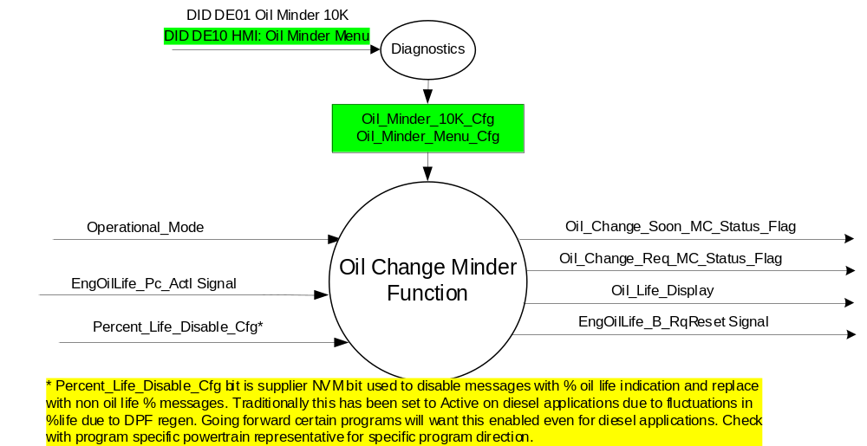

Inputs
      - INTERNAL:
          - Operational_Mode
          - Percent_Life_Disable_Cfg
          - Oil_Minder_10K_Cfg
          - Oil_Minder_Menu_Cfg

      - MUX message on the CAN bus from the PCM

- EngOilLife_Pc_Actl Signal
Signal Name | Size  (bits) | Detail | Units | Res. | Offset | State Encoded | Min. | Max.
EngOilLife_Pc_Actl | 7 |  | Percent | 1 | 0 |  | 0 (0x0) | 100 (0x64)

Outputs
- Oil_Change_Soon_MC_Status_Flag that is used to control the Warning displayed in the message center.
- Oil_Change_Req_MC_Status_Flag that is used to control the Warning displayed in the message center.
- Oil_Life_Display that is used to control the System Check value displayed in the message center.
- MUX message on the CAN bus to the PCM

- EngOilLife_B_RqReset Signal
Signal Name | Size  (bits) | Detail | Units | Res. | Offset | State Encoded | Min | Max
EngOilLife_B_RqReset | 1 |  | SED | 1 | 0 |  | 0 (0x0) | 1 (0x1)
 |  | No |  |  |  | 0x0
 |  | Yes |  |  |  | 0x1

Function/Performance

Operational Modes

Mode | Differentiating Vehicle Conditions
Sleep Mode | OIL CHANGE MINDER INACTIVE
Limited Mode | OIL CHANGE MINDER INACTIVE
Normal Mode | OIL CHANGE MINDER ACTIVE
Crank Mode | OIL CHANGE MINDER ACTIVE

Voltage Levels

Refer to the Cluster Features Table located in the Operational Modes and Voltage Range Strategies Section of this SPSS

Human-Machine Interface

Visual

Indicator Graphics / Display Format
Reference the following Message IDs in the Text Message List file for the appropriate display:
Percent_Life_Disable_Cfg = Inactive (non-diesel applications) then:
W470, W475.

Percent_Life_Disable_Cfg = Active (certain diesel applications – contact powertrain diesel representative for direction) then:
W470, W475

Example Oil Life Reset menu:
This is displayed only when Oil_Minder_Menu_Cfg = 0x0 (Enabled)

Menu level 2 |  | Menu level 3 |  | Menu level 4
Vehicle |  | T: Vehicle
 |  | Oil Life Reset |  | T: Oil Life Reset
 |  | Oil Life Reset |  | Set to 100% (Default setting)

Indicator Color Coordinates
Reference section COLOR & ILLUMINATION REQUIREMENTS (GRAPHICS)

Indicator Characteristics

Refer to Message Center X Display_Y Button Interface Section, where X and Y are appropriate values in this document.

Audio

No Message Center Warning Chime is associated with this Warning.

Switch Control Logic

Refer to Message Center X Display_Y Button Interface Section, where X and Y are appropriate values in this document, for System Check and Warning behavior.

System Accuracy

Oil Change Minder Function shall be processed by the Message Center so that any human requests are processed within 100 ms of receipt of request.

Operation: Performance and Functional

Subsystem Algorithm Flowchart / State Diagrams

Oil Life CAN Diagnostic

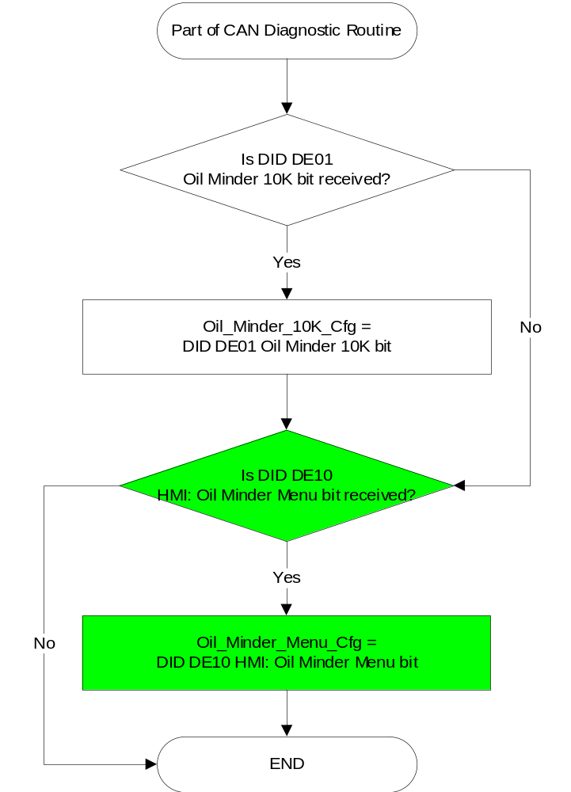

Oil Life – Main Loop

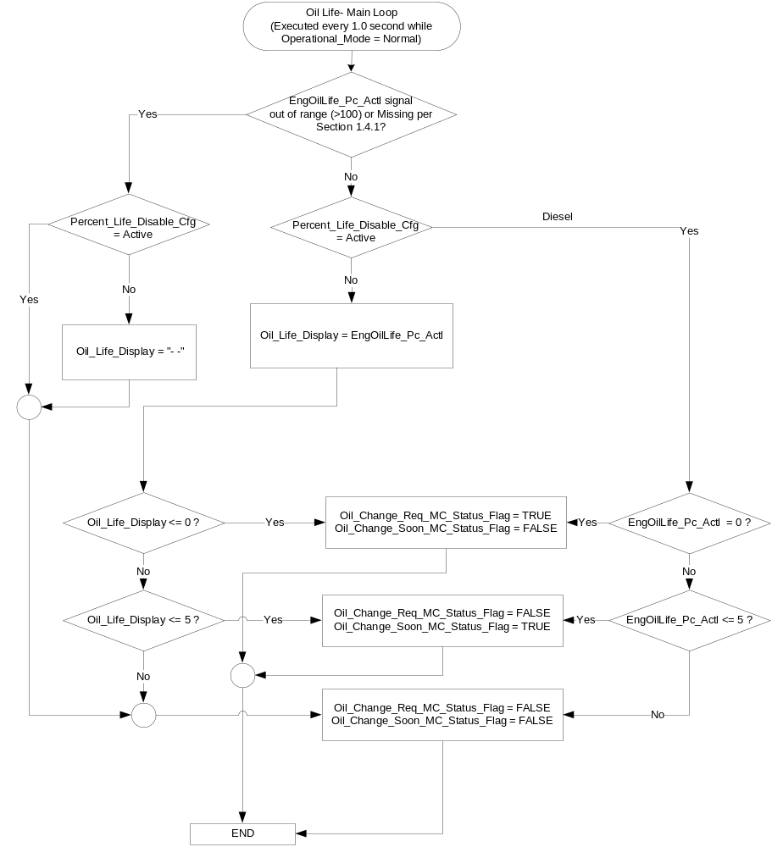

Oil Life – Resetting for New Oil
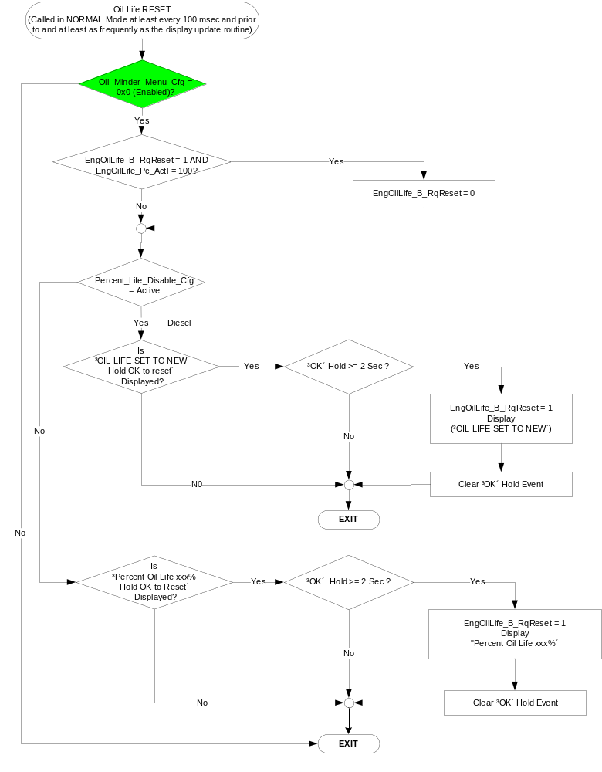

Operation Description (supports algorithm flowchart /state diagram)

- If Oil_Minder_10K_Cfg = 0, then the oil minder function shall be disabled. The message center warning flags shall be disabled and the display shall not be shown in system check.
- The engine oil life information shall be given to the driver in system check or on warning activation.
- If Percent_Life_Disable_Cfg = 0, SC500 is displayed in system check. If Percent_Life_Disable_Cfg = 1, SC502 is displayed in system check.
- If Oil_Change_Req_MC_Status_Flag = True, W470 is active and also replaces SC500 / SC502 in system check.
- If Oil_Change_Soon_MC_Status_Flag = True, W475 is active and also replaces SC500 / SC502 in system check.
- Oil life displayed shall be the value of the engine oil life signal from the PCM (EngOilLife_Pc_Actl)

Function Safety Classification (EMC)

Class A

Memory Storage

Variable Name | Type of Storage | Description | Value at Battery Connect | Value at Module Wake-up | Minimum Range | Initial Value from Cluster Plant | Units
Oil_Minder_10K_Cfg | EEPROM | State Variable used to Configure for Oil Life Minder Function | Use Stored Value | Use Stored Value | 0-1 | 1 | 0 – Disabled  1- Enabled
Oil_Minder_Menu_Cfg | EEPROM | State Variable used to Configure for display of Oil Life Reset Menu Function | Use Stored Value | Use Stored Value | 0-1 | 1 | 0 – Enabled  1- Disabled
Percent_Life_Disable_Cfg | EEPROM | NVM bit programmed at supplier to determine whether percent oil life messages are replaced by messages which do not indicate percent oil life | Use Stored Value | Use Stored Value | - | 0 or 1 | 0 = Inactive  1 = Active
OLPC_SET | EEPROM | Driver selected adjustment to oil life in increments of 10% | Use Stored Value | Use Stored Value | 10-100 | 100 | %

Variable Name | Type of Storage | Description | Value at Battery Connect | Value at Module Wake-up | Minimum Range | Units
Oil_Change_Req_MC_Status_Flag | RAM | Flag used by display manager to trigger OIL CHANGE REQUIRED warning | FALSE | Do Not Init | - | -
Oil_Change_Soon_MC_Status_Flag | RAM | Flag used by display manager to trigger CHANGE OIL SOON warning | FALSE | Do Not Init | - | -
Oil_Life_Display | RAM | Value of EngOilLife_Pc_Actl signal | 100 | Do Not Init | 0-100 | %
EngoilLife_B_Rqreset Signal | RAM | Indicator to the PCM that the oil life has been reset through the message center.  (once reset, this value is latched to 1 for the duration of the ignition cycle) | 0 | 0 | - | -
EngOilLife_Pc_Actl Signal | RAM | CAN Signal Received from the PCM | 100 | Do Not Init | 0-100 | %

Prove Out

None.

Reconfigurable Telltale

No

Message Center Msg

Reference the following Message IDs in the Text Message Center List file for the appropriate display:
Percent_Life_Disable_Cfg = Inactive (non-diesel applications) then:
W470, W475.

Percent_Life_Disable_Cfg = Active (diesel applications) then:
W470, W475

Error Handling

Missing Message Strategy

The signals will be declared missing as per the Diagnostics section of this SPSS.

DTCs states and history will be determined as per the Diagnostics section of this SPSS.

Diagnostics

Self Test

None

Engineering Test Mode

Reference section “Dealer / Engineering Test Mode (ETM)”

Part II Performance

Supported Diagnostic Trouble Codes (DTCs)
DTC | Description
C10000 | Lost communication with ECM/PCM

DID $DExx
Block  Num | Block Description | Size (bits) | Type | Byte(s) | Bits | State: Description | "0" | "1" | Default | Comments/  Information
PACKETED BLOCKS
$01 | Option Content (B&A) | 40 | 1 | * | * | Oil Minder 10K | Disable(d) | Enable(d) | Enable(d) | 1 – Enables oil minder displays in cluster. 0 – Disables displays  NOTE: CLUSTER ALWAYS CALCULATES AND TRANSMITS OdometerMasterValue HSCAN SIGNAL REGARDLESS OF CONFIGURATION. (Refer to Odometer Indication Display SPSS).
$10 | Option Content (B&A) | 40 | 1 | * | * | HMI: Oil Minder Menu | Enable(d) | Disable(d) | Enable(d) | Note reverse logic! Enabled is 0 for compatibility reasons.  This parameter when Enabled allows the cluster to display the Oil Life Reset menu.  Disable on all 2.0L Panther diesel engines.
*Byte and bit location to be identified in Part II Specification for this cluster

Reference Specification

Revision History

SPSS Module Revision History

Revision Level | Name | Change Description | Date
1.0 | V. Patel | Updated for CGEA 1.3 based on CGEA STSS v3.0  Section 1.2.2 – Removed table referencing the HS-CAN message that contains the input signal.  Section 1.2.3 – Removed table referencing the HS-CAN message that contains the output signal.  Section 1.2 – Deleted “Position” column from the input and output signal tables.  Section 1.4 – Rewritten. Deleted references of specific missing message flags and timer.  Section 1.5.3 – Deleted DTC logging criteria from the table. | 4/20/2010
1.1 | S. Watkins  M. Hakim | Update to remove the Offset calculations and cleanup. Details are as follows:  Updated Flowcharts of Sections 1.3.5.1.2 and 1.3.5.1.3  Updated Configuration DID DE00 to DExx throughout the document  Section 1.2.2: Listed the inputs and removed the outputs from the Internal Inputs list.  Removed SU635 and SU315 throughout the document  Section 1.3.5.4: Added CAN Signal EngOilLife_Pc_Actl to the Memory Storage Table  Updated document footer | 9/17/2013
1.2 | T. Cwik | Minor clean-up  Section 1.1 – Removed “, less any driver selected offset,” and “, thus, % Oil Life is replaced by Oil Life OK message in system check.” | 10/25/2013
1.3 | J.Blatchford | This minor update identifies that certain diesel programs want to display % Oil Life going forward where in the past this has typically been suppressed on diesel applications using Percent_Life_Disable_Cfg. Contact your diesel powertrain contact for direction on how to set this bit on your program.  - 1.1: Added paragraph  - 1.2.1: Updated note to context diagram.  - 1.3.3.2: Updated note. | 4/6/2016
V36x Specific 1.0 | S. Watkins | Based off of Oil Change Minder 10K and Diesel - CGEA1.3_v1.3.doc.  This version is V36x Specific and should not be used by other programs.  The V36x program has a unique request. Due to high engine warranty, it was determined that customers are simply resetting the oil life warning WITHOUT actually changing the oil. This has led to the request to add a unique DE10 configuration bit (HMI: Oil Minder Menu) that would allow you to disable the oil life reset menu display in the cluster. The normal config is still used, since we still want the 2 warnings. At this time, this will be limited to S0, S1, S2 level clusters. This is why the new config bit will be put in the S-family specific HMI area in DE10 and not into the global config. At this time, we do not want to add this to other programs. (As an FYI, the customer will have to use the PCM controlled “hidden” method of using the accelerator pedal to reset oil life).  Changes marked in green:  - Section 1.1 – Updated description  - Section 1.2.1 – Updated Figure with new config (Oil_Minder_Menu_Cfg)  - Section 1.2.2 – Updated with new config  - Section 1.3.3.2 – Added HMI example for oil life reset menu  - Section 1.3.5.1.1 – Added new config  - Section 1.3.5.1.3 – Added new decision diamond using new config  - Section 1.3.5.4 – Added new config  - Section 1.5.3 – Added new config | 12/18/2018

